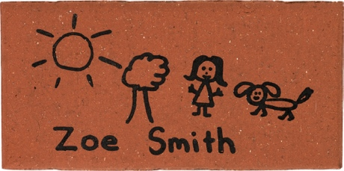

To celebrate Yoogali Public School’s centenary, we are offering commemorative pavers for sale as a memento. Families, community members and organisations are invited to purchase personally engraved pavers, which will be showcased in our school grounds.

**Celebrating 100 years of public education at**

**Yoogali Public School 1917-2017**

**DONATION OF $30**

Provides you with a personalised engraved paver in recognition of your contribution and support.

Please follow instructions and complete drawing on attached page to successfully generate a quality paver drawing.

(organisers – please ensure this is printed on 2 pages – not single sheet front and back)

**Offer closes 14th October, 2017**

|  |  |  |  |  |  |  |
| --- | --- | --- | --- | --- | --- | --- |
| **CONTACT DETAILS AND PAYMENT OPTIONS :** | | | | | | |
| **Name** | | | **Phone** | | **Donation Amount** | |
|  | | |  | | $ | |
| **Payment Options** (please circle) **: CASH CHEQUE CARD** | | | | | | |
| Cheques to be made out to : | | {Account Details} | | | | |
| Credit Card Payments Option : Credit Card Type (please circle) Visa / Master Card | | | | | | |
| Name on Credit Card : |  | | | | | |
| Credit Card Number | | | | Expiry Date | | CRC Number |

/



NAME (same as form):

**DRAW WITHIN THE DOTTED LINE BOX BELOW.**

Anything drawn outside the box will NOT be engraved

(ORGANISERS – PLEASE PHOTOCOPY AND SEND ORIGINAL TO DESIGN A BRICK)

2mm test line

**Good Drawing Sample**

* Simple sketch
* Large writing
* Thick Lines

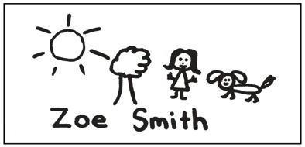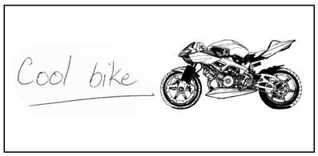

**Poor Drawing Sample**

* Digital Drawing
* Used Pen
* Thin lines



**Follow these simple RULES to produce a quality engraved paver**

* Use only a quality **BLACK** marker pen with a tip size **NO LESS THAN 2MM THICK**. Check with test line at the bottom of the page.
* We recommend an **ARTLINE 70** or **SHARPIE** bullet point markers available at most stationery stores or supermarkets.
* **Do not use ball point pens, pencils, crayons or coloured markers**.
* If you are drawing over a pencil sketch, ensure that all pencil marks have been erased.
* Keep drawing and text large and simple. Do not use fine details, as they will not appear on the finished product.
* Do not use digital images. The engraving process has been setup for hand drawn images only.

**INSTRUCTIONS FOR HAND DRAWN PAVERS**